EDGE INTELLIGENCE ASSIGNMENT
G.PALLAVI(25MML0033)
1) LOAD THE DATA
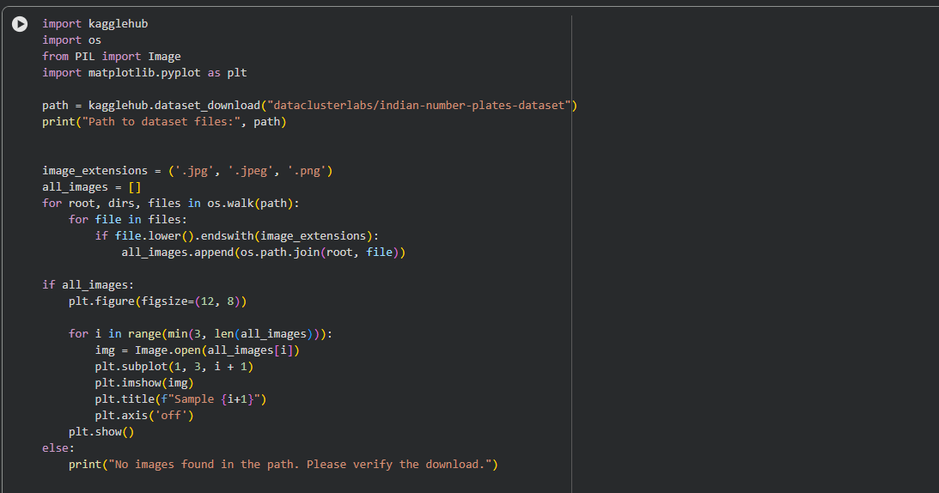

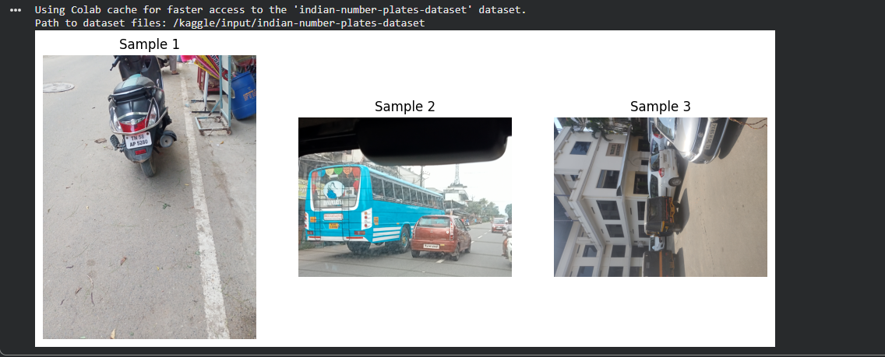

2)RESHAPE
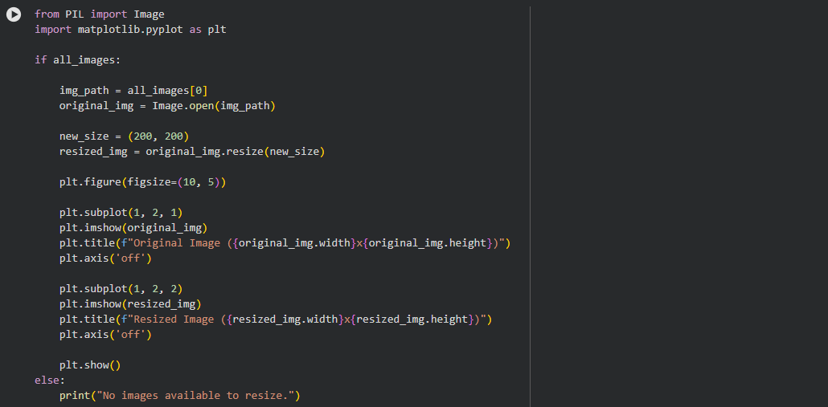
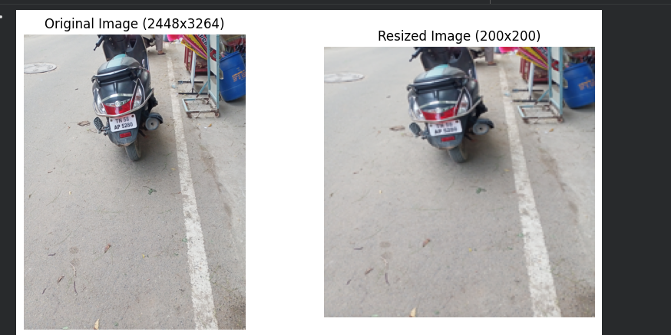

3)TRAIN TEST SPLIT:
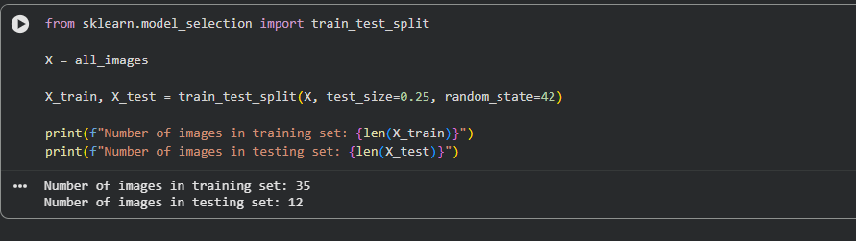
4)Use PICKLE and save it
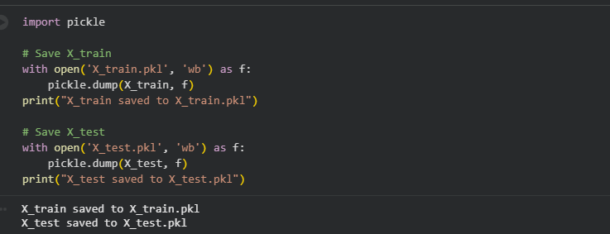

5)Get the weight
